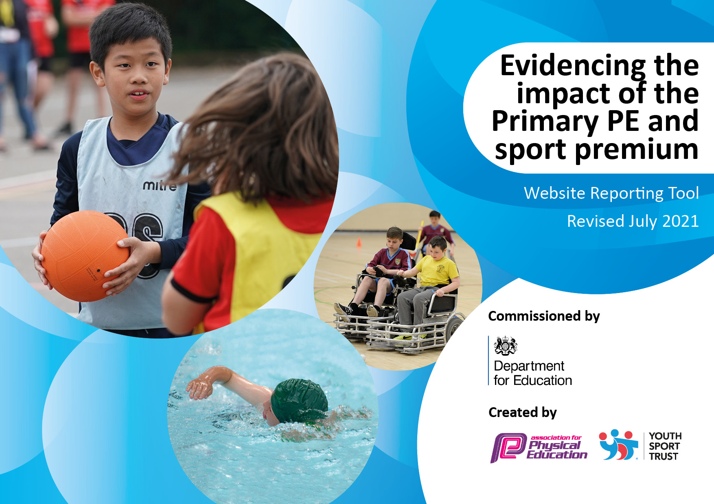
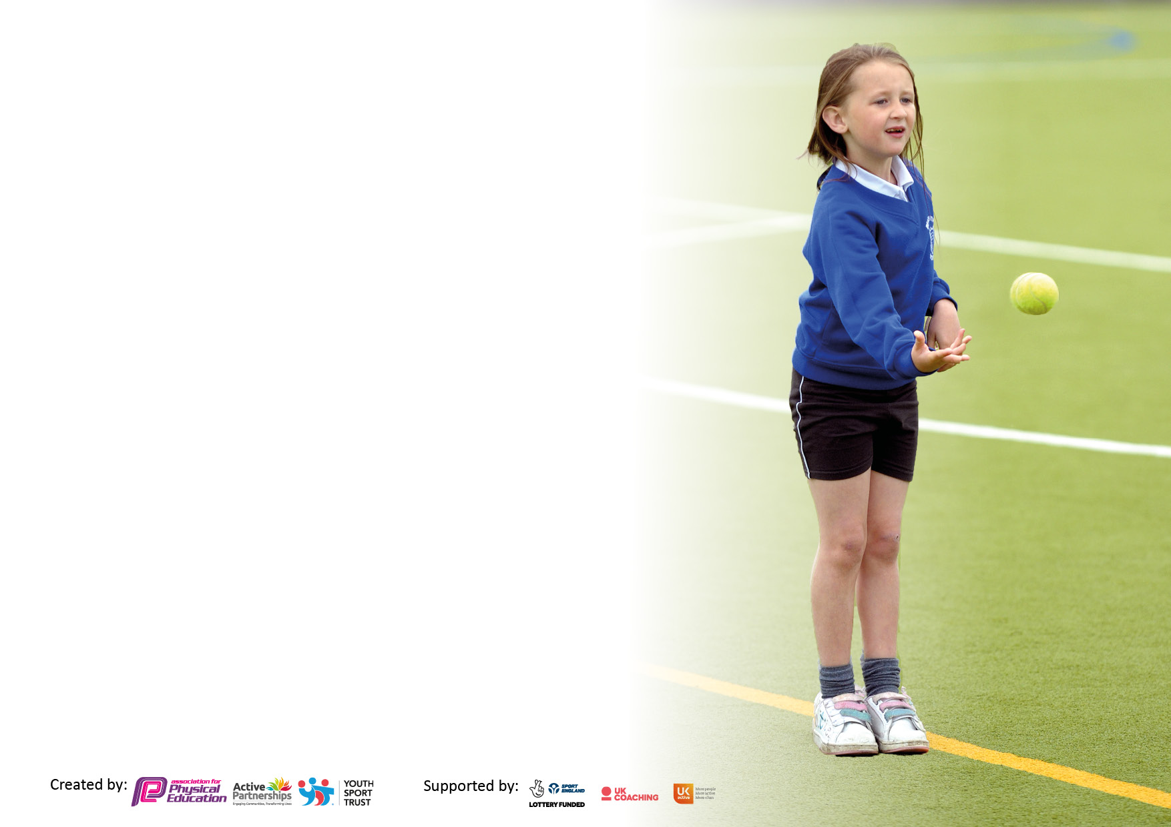

It is important that your grant is used effectively and based on school need. The Education Inspection Framework makes clear there will be a focus on ‘whether leaders and those responsible for governors all understand their respective roles and perform these in a way that enhances the effectiveness of the school’.

Under the Quality of Education Ofsted inspectors consider:
Intent - Curriculum design, coverage and appropriateness
Implementation - Curriculum delivery, Teaching (pedagogy) and Assessment
Impact - Attainment and progress

To assist schools with common transferable language this template has been developed to utilise the same three headings which should make your plans easily transferable between working documents.

Schools must use the funding to make additional and sustainable improvements to the quality of Physical Education, School Sport and Physical Activity (PESSPA) they offer. This means that you should use the Primary PE and sport premium to:

- Develop or add to the PESSPA activities that your school already offer
- Build capacity and capability within the school to ensure that improvements made now will benefit pupils joining the school in future years
- The Primary PE and sport premium should not be used to fund capital spend projects; the school’s budget should fund these.

Pleasevisitgov.ukfortherevisedDfEguidanceincludingthe5keyindicatorsacrosswhichschoolsshoulddemonstrate animprovement.Thisdocumentwillhelpyoutoreviewyourprovisionandtoreportyourspend.DfEencouragesschools to use this template as an effective way of meeting the reporting requirements of the Primary PE and sport premium.

We recommend you start by reflecting on the impact of current provision and reviewing the previous spend.

Schools are required to publish details of how they spend this funding, including any under-spend from 2019/2020, as well as on the impact it has on pupils’ PE and sport participation and attainment. All funding must be spent by 31st July 2022.

We recommend regularly updating the table and publishing it on your website throughout the year. This evidences your ongoing self-evaluation of how you are using the funding to secure maximum, sustainable impact. Final copy must be posted on your website by the end of the academic year and no later than the 31st July 2021. To see an example of how to complete the table please click HERE.
Created by: Supported by:

Details with regard to funding
Please complete the table below.

Total amount carried over from 2021/22 | £0
Total amount allocated for 2022/23 | £17240.00
How much (if any) do you intend to carry over from this total fund into 2023/24? | £590.83
Total amount allocated for 2022/23 | £17280.00
Total amount of funding for 2022/23. To be spent and reported on by 31st July 20223 | £16689.17
Swimming Data
Please report on your Swimming Data below.

Meeting national curriculum requirements for swimming and water safety.

N.B. Complete this section to your best ability. For example you might have practised safe self-rescue techniques on dry land which you can then transfer to the pool when school swimming restarts.
Due to exceptional circumstances priority should be given to ensuring that pupils can perform safe self rescue even if they do not fully meet the first two requirements of the NC programme of study
What percentage of your current Year 6 cohort swim competently, confidently and proficiently over a distance of at least 25 metres?  N.B. Even though your pupils may swim in another year please report on their attainment on leaving primary school at the end of the summer term 2021.  Please see note above | 65%
What percentage of your current Year 6 cohort use a range of strokes effectively [for example, front crawl, backstroke and breaststroke]?  Please see note above | 65%
What percentage of your current Year 6 cohort perform safe self-rescue in different water-based situations? | 55%
Schools can choose to use the Primary PE and sport premium to provide additional provision for swimming but this must be for activity over and above the national curriculum requirements. Have you used it in this way? | Yes extra sessions for the y6 children

Action Plan and Budget Tracking
Capture your intended annual spend against the 5 key indicators. Clarify the success criteria and evidence of impact that you intend to measure to evaluate for pupils today and for the future.

Academic Year: 2021/2022 | Total fund allocated: | Date Updated:
Key indicator 1: The engagement of all pupils in regular physical activity – Chief Medical Officers guidelines recommend that primary school pupils undertake at least 30 minutes of physical activity a day in school |  |  |  | Percentage of total allocation:
 |  |  |  | 27%
Intent | Implementation |  | Impact | £10206.17
Your school focus should be clear what you want the pupils to know and be able to do and about  what they need to learn and to  consolidate through practice: | Make sure your actions to achieve are linked to your intentions: | Funding allocated: | Evidence of impact: what do pupils now know and what can they now do? What has changed?: | Sustainability and suggested next steps:
All pupils take part in 30-60 minutes of physical activity per day, with greater numbers enjoying active sessions.  •Creates calmer lunchtimes with fewer arguments  •Increases pupil participation in activities  •Increases interest in sport and a healthy lifestyle  •Prepares children for their daily learning  •Contributes towards the engagement of all pupils in regular physical activity  •Provides a broad experience of a range of sports and activities  Also fits in key Indicator 4 | •Regular checks of the PE container to check for wear and tear and replacements needed. £4000  •Regular checks with the staff to ask for any equipment needed  £2000  •Line marking on the field for athletics and rounders in the summer £200 | £6200  Actual Spent:  £2,500 (playground lines remarked for sport) | •Enables range of sports and activities to be taught  •Lessons not cancelled/adjusted due to poor quality or quantity of equipment | •Continue regular checks of the PE container will keep resources sustainable for the foreseeable future  •Re-iterate need for staff to inform me of broken/damaged equipment
Maintenance and replacement of equipment (based on recommendations from safety inspection)  •Ensures equipment is safe to use  •Reduced risk of accidents/injuries  •Sustains lifespan of equipment | •Go through list of recommendations  •Discuss queries with inspector(s)  •Agree to selected recommendations | £1200.00  Actual Spent:  £2591.17 | •Safer environment for pupils  •Equipment use is not limited | •Inspection system is already sustainable  •Re-iterate need for staff to inform me of broken/damaged equipment
Pay for a lunch time play leader  •All children will have the opportunity to take part in lunch time competitions  •Aids towards increasing pupil participation in competitive sport.  •Contributes towards the engagement of all pupils in regular physical activity •Children will spend their lunch time being physically active  •The less active children are engaged in activities that they enjoy and are being encouraged to be physically active.  •Provides a broad experience of a range of sports and activities •Increases pupil motivation •Raises standard of pupil performance  •Raises the profile of PE across the school  Also fits in Key Indicators 2, 4 & 5 | •Regular discussions with the leader over the implementation of lunch time activities  •Regular contact and checking how the groups are going  •Ask the children who would like to take part | £1000  Actual Spent:  £1,122 | •Sports leader said sessions were well attended and enjoyed | • Lunch time activities sustainable for another year  • Look into ways of making it more accessible for the less active children
Pay for Pupil Premium clubs  •This enables and encourages our Pupil Premium children to take part in extracurricular sports-based activities which they may otherwise have been unable to do.  •Increases interest in sport and a healthy lifestyle | •Send a letter to all pupil premium children notifying them of a free place | £600  Actual Spent:  £600 | •Increased participation (4 children) in extracurricular sporting activities due to pupil premium children joining in clubs they otherwise wouldn’t have.  •The children are more aware of how regular exercise can benefit their health and wellbeing. | •See if Progressive Sports can come in again next year to continue this club as the children really enjoyed it.  •Engage the parents more in this club and ask them to continue to support at home.
Y5/6 swimming  •Ensures our children are confident with a lifesaving skill | •Assess the children to see if they can swim 25m | Swimming lessons  £463  Coach cost  £2,880  Actual Spent:  £3343 | The children have more confidence in the water. | •Have rebooked swimming lessons next year.  •Year 4/5 attending swimming next year as missed out this year
Breakfast and afterschool club to promote physical activity for pupils that are teacher led to promote regular physical activity.  •Increases interest in sport and a healthy lifestyle  •Raises the profile of PE across the school | • Implement the club in ASC and discuss the impact with Mrs Tysall. | £100  Actual Spent:  £50 | •Purchase of sports equipment has enabled afterschool club to be physically active afterschool. Children love the use of the glow sticks and disco light. | •To continue to communicate with Mrs Tysall to discuss resources needed for Zumba afterschool.
Key indicator 2: The profile of PESSPA being raised across the school as a tool for whole school improvement |  |  |  | Percentage of total allocation:
Intent | Implementation |  | Impact | £1070
Your school focus should be clear what you want the pupils to know and be able to do and about  what they need to learn and to  consolidate through practice: | Make sure your actions to achieve are linked to your intentions: | Funding allocated: | Evidence of impact: what do pupils now know and what can they now do? What has changed?: | Sustainability and suggested next steps:
Pay for a TA/cover to support/cover the sports lead.  •Helps to ensure children can attend external sporting events with all the background preparation  •Entering the marathon data ensures regular and consistent feedback for children of their achievements and helps them to identify their own achievements and targets. | •Check availability in advance of event | £1000  Actual Spent:  £970 | Learning walk has been able to be taken place to see the strengths and areas for development in PE throughout the school.  Sports Lead has been able to attend competitions and taken the children to and from events to raise the profile of PE in the school. | • Continue this next year
To promote achievements in school  •During assembly time and at the end of term to promote sport in the school, including celebration with parents.  •Present the children with medals for the Marathon challenge in the Summer Term. | •To purchase trophies for children who have taken part in the Marathon Challenge throughout the year in summer term. | £500.00  Actual Spent:  £100 | •The children have loved discussing their achievements in assembly and are bringing in other trophies/certificates from sporting events they take part in at home. | •Produce an excel spreadsheet of children who have attended clubs and tournaments.
To make all resources easily assessible to all staff. | •Buy a storage container for all of the PE resources so that all staff and external coaches can get to the indoor and outdoor PE equipment. | £1700.00  Actual Spent: completed last year | •Staff have commented on the ease of having all of the resources in one place and being able to find things quickly and easily to set up for PE lessons and clubs. | •Continue to check the container for resources that need replacing and ask the sports leads to do an audit and stock check on what we need in the future.

Key indicator 3: Increased confidence, knowledge and skills of all staff in teaching PE and sport |  |  |  | Percentage of total allocation:
Intent | Implementation |  | Impact | £1774
Your school focus should be clear | Make sure your actions to | Funding | Evidence of impact: what do | Sustainability and suggested
what you want the pupils to know | achieve are linked to your | allocated: | pupils now know and what | next steps:
and be able to do and about | intentions: |  | can they now do? What has
what they need to learn and to |  |  | changed?:
consolidate through practice:
To increase the confidence and knowledge of members of staff who teach P.E. (teachers and TA’s) | To use qualified sports coach to work alongside teachers to team teach- enhance or extend current opportunities. (Tennis coaches from Lichfield Cathedral School) | £100.00  Actual Spent:  £100 | •The children have commented on the lessons, “I love tennis it is so much fun!” Y4 child | •Look for other sports coaches for next year, questionnaire what sport children would like – ultimate frisbee?
To lead staff meetings and gather information about staff confidence in teaching PE through questionnaires |  | £500.00  Actual Spent:  194
Raise the quality of learning and teaching in PE and school sport by providing support to deliver broad, balanced and inclusive high quality PE and school sport provision (within and beyond the curriculum) to raise pupils’ attainment.  Forest School Training for Ms Walton – she has been on external training to implement activities in the school’s secret garden. | • Use specialist coaches (Wendy Gleeson) and providers for staff training for TA’s to increase the knowledge and confidence of staff in delivering PE.  •Ask staff members to go and observe and support Wendy in delivering her lessons to help upskill TA’s through modelling lessons, team teaching, help with planning and observations. | £1000.00  Actual Spent:  £2240 | • Enhanced quality of provision •Increased pupil participation in competitive activities and events.  •Increased range of opportunities.  •The sharing of best practice. | •Review staff confidence and competence in delivering high quality PE and school sport and allocate staff to upcoming CPD opportunities  •Further 1:1 lesson observation to monitor staff effectiveness and confidence
Key indicator 4: Broader experience of a range of sports and activities offered to all pupils |  |  |  | Percentage of total allocation:
Intent | Implementation |  | Impact | £3069
Your school focus should be clear | Make sure your actions to | Funding | Evidence of impact: what do | Sustainability and suggested
what you want the pupils to know | achieve are linked to your | allocated: | pupils now know and what | next steps:
and be able to do and about | intentions: |  | can they now do? What has
what they need to learn and to |  |  | changed?:
consolidate through practice:
Support and involve the least active children by providing targeted activities, and running or extending school sports.  • To run a rounders club  •To run a football club for KS2  • To run a netball club for KS2  •To run a multiskills club for KS1 | •All children from the 2’s room to Year 6 take part in the whole school sports day.  •To learn new skills of throwing and catching, teamwork, knowledge of a new sport. | £1920.00  Actual Spent:  £3069.00 | •There is a greater uptake in the ASC and lunchtime clubs.  68% of the children are taking part in some club BS, AS or during school.  •The children are more engaged and more active.  •There is a real enjoyment from the children, “After school clubs are the best!” (Year 3 child)  •Engaged or re-engaged disaffected pupils - Increased pupil participation  •Enhanced quality of delivery of activities - Increased staffing capacity and sustainability - Enhanced, extended, inclusive extra-curricular provision.  •Improved behaviour and attendance and reduction of low-level disruption at lunchtimes and breaktimes. | •Continue to offer additional extracurricular opportunities for all pupils to take part in physical activity and sport  •Providing additional links to Community Sports Clubs

Key indicator 5: Increased participation in competitive sport |  |  |  | Percentage of total allocation:
Intent | Implementation |  | Impact | £570
Your school focus should be clear | Make sure your actions to | Funding | Evidence of impact: what do | Sustainability and suggested
what you want the pupils to know | achieve are linked to your | allocated: | pupils now know and what | next steps:
and be able to do and about | intentions: |  | can they now do? What has
what they need to learn and to |  |  | changed?
consolidate through practice:
Pay for children to attend competitions  •Increases pupil motivation  •Enhances our inclusive provision •Enhances a positive attitude and engagement in and towards competition  •Raises the profile of PE across the school  •Allows all pupils to attend competitions  Also fits in Key Indicator 2 | •Speak to James EDASGO about which competitions we can take part in over the year.  •Make sure SEND children have an opportunity to take part in competitions.  •Ensure a range of sporting types are entered  •Enter inclusive competitions/events •Provide staff with information regarding how to undertake competitions | £1000.00  Actual Spent:  £570 | 62% of the school have participated in competitions (up from last year).  •SEND children have taken part | •Ensure all year groups have a competition to take part in.

Signed off by
Head Teacher:
Date:
Subject Leader:
Date:
Governor:
Date:

