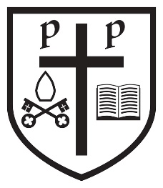Recovery Curriculum at SS Peter and Paul Catholic Primary

Children have spent a long time out of school due to Covid-19. The most important aspect of our recovery curriculum is the chance to be able to talk about their worries and concerns in a safe and supported way. We have extra wellbeing lessons into our curriculum and look at topics such as worries, friendships and self-esteem. Children will be supported in all aspects of wellbeing over these first fragile months back to school.
In order to ascertain what gaps the children have in their learning, they will be assessed in English and Maths in the first few weeks back at school. These standardised tests will show what areas of the curriculum the children need further support in. These tests will be termly and inform teachers of gaps in learning.
The information gathered from these tests will help the class teachers plan for lessons and ensure that objectives are covered at a level the children are working at.
In the Autumn term, the teachers will work on objectives from the previous year the children were in, as well as their current year. With the extra support we have placed into each class, we anticipate the children will make more rapid progress.
Some children who have more extensive gaps in learning will receive 1:1 or small group intervention in areas they find difficult.
We will use funding from the DFE to provide tutoring for some targeted children to help them to gain expected standard by the end of the academic year. We will use catch up funding to support children in Y2 and Y5 to provide small group sessions with trained teachers in Maths and English.

