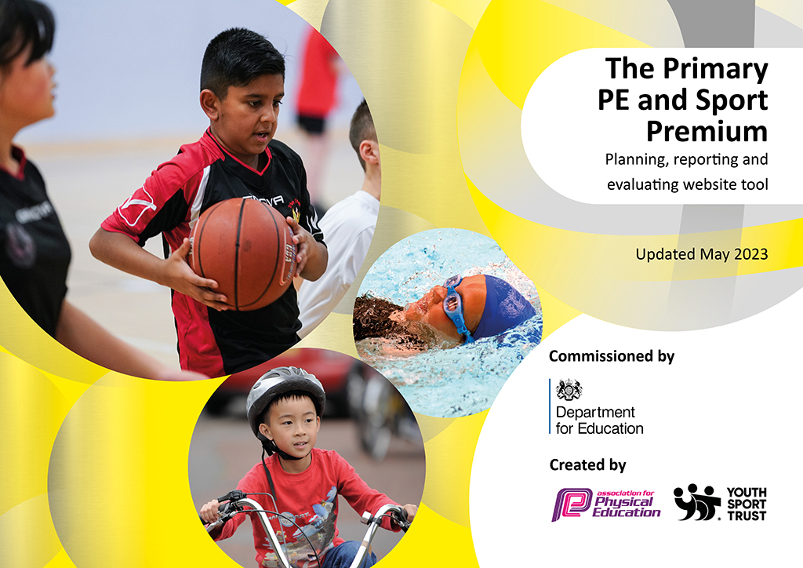
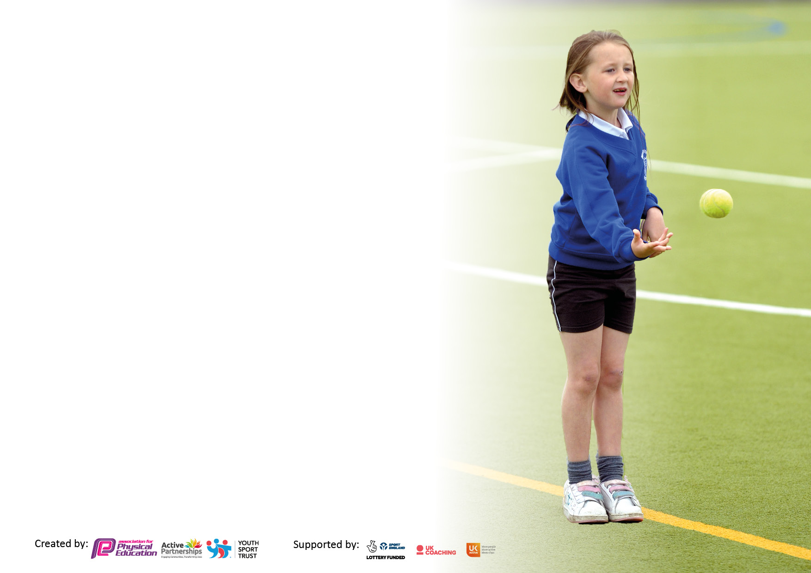

It is important that your grant is used effectively and based on school need. The Education Inspection Framework makes clear there will be a focus on ‘whether leaders and those responsible for governors all understand their respective roles and perform these in a way that enhances the effectiveness of the school’.

Under the Quality of Education Ofsted inspectors consider:
Intent - Curriculum design, coverage and appropriateness
Implementation - Curriculum delivery, Teaching (pedagogy) and Assessment
Impact - Attainment and progress

To assist schools with common transferable language this template has been developed to utilise the same three headings which should make your plans easily transferable between working documents.

Schools must use the funding to make additional and sustainable improvements to the quality of Physical Education, School Sport and Physical Activity (PESSPA) they offer. This means that you should use the Primary PE and sport premium to:

- Develop or add to the PESSPA activities that your school already offer
- Build capacity and capability within the school to ensure that improvements made now will benefit pupils joining the school in future years
- The Primary PE and sport premium should not be used to fund capital spend projects; the school’s budget should fund these.

Pleasevisitgov.ukfortherevisedDfEguidanceincludingthe5keyindicatorsacrosswhichschoolsshoulddemonstrate animprovement.Thisdocumentwillhelpyoutoreviewyourprovisionandtoreportyourspend.DfEencouragesschools to use this template as an effective way of meeting the reporting requirements of the Primary PE and Sport Premium.

We recommend you start by reflecting on the impact of current provision and reviewing the previous spend.

Schools are required to publish details of how they spend this funding, including any under-spend from 2021/2022, as well as on the impact it has on pupils’ PE and sport participation and attainment. All funding must be spent by 31st July 2023.

We recommend regularly updating the table and publishing it on your website throughout the year. This evidences your ongoing self-evaluation of how you are using the funding to secure maximum, sustainable impact. Final copy must be posted on your website by the end of the academic year and no later than the 31st July 2023. To see an example of how to complete the table please click HERE.
Created by: Supported by:

Details with regard to funding
Please complete the table below.

Total amount carried over from 2022/23 | £590.83
Total amount allocated for 2023/24 | £17320
How much (if any) do you intend to carry over from this total fund into 2024/25? | £
Total amount allocated for 2023/24 | £17910.83
Total amount of funding for 2023/24. To be spent and reported on by 31st July 2024. | £
Swimming Data
Please report on your Swimming Data below.

Meeting national curriculum requirements for swimming and water safety.

N.B. Complete this section to your best ability. For example you might have practised safe self-rescue techniques on dry land which you can then transfer to the pool when school swimming restarts.
Due to exceptional circumstances priority should be given to ensuring that pupils can perform safe self rescue even if they do not fully meet the first two requirements of the NC programme of study
What percentage of your current Year 6 cohort swim competently, confidently and proficiently over a distance of at least 25 metres?  N.B. Even though your pupils may swim in another year please report on their attainment on leaving primary school at the end of the summer term 2022.  Please see note above | %
What percentage of your current Year 6 cohort use a range of strokes effectively [for example, front crawl, backstroke and breaststroke]?  Please see note above | %
What percentage of your current Year 6 cohort perform safe self-rescue in different water-based situations? | %
Schools can choose to use the Primary PE and sport premium to provide additional provision for swimming but this must be for activity over and above the national curriculum requirements. Have you used it in this way? | Yes/No

Action Plan and Budget Tracking
Capture your intended annual spend against the 5 key indicators. Clarify the success criteria and evidence of impact that you intend to measure to evaluate for pupils today and for the future.

Academic Year: 2022/23 | Total fund allocated: | Date Updated:
Key indicator 1: The engagement of all pupils in regular physical activity – Chief Medical Officers guidelines recommend that primary school pupils undertake at least 30 minutes of physical activity a day in school |  |  |  | Percentage of total allocation:
 |  |  |  | %
Intent | Implementation |  | Impact
Your school focus should be clear what you want the pupils to know and be able to do and about  what they need to learn and to  consolidate through practice: | Make sure your actions to achieve are linked to your intentions: | Funding allocated: | Evidence of impact: what do pupils now know and what can they now do? What has changed?: | Sustainability and suggested next steps:
All pupils take part in 30-60 minutes of physical activity per day, with greater numbers enjoying active sessions.  •Creates calmer lunchtimes with fewer arguments  •Increases pupil participation in activities  •Increases interest in sport and a healthy lifestyle  •Prepares children for their daily learning  •Contributes towards the engagement of all pupils in regular physical activity  •Provides a broad experience of a range of sports and activities  Also fits in key Indicator 4  Maintenance and replacement of equipment (based on recommendations from safety inspection)  •Ensures equipment is safe to use  •Reduced risk of accidents/injuries  •Sustains lifespan of equipment | Regular checks of the PE container to check for wear and tear and replacements needed. £150  •Regular checks with the staff to ask for any equipment needed  £2000  •Line marking on the field for athletics and rounders in the summer £200  Go through list of recommendations  •Discuss queries with inspector(s)  •Agree to selected recommendations  Sports safe check on internal PE equipment | £2350  2500  Actual spend
Pay for a lunch time play leader  And install play/ gym equipment for use at playtimes  •All children will have the opportunity to take part in lunch time competitions  •Aids towards increasing pupil participation in competitive sport.  •Contributes towards the engagement of all pupils in regular physical activity •Children will spend their lunch time being physically active  •The less active children are engaged in activities that they enjoy and are being encouraged to be physically active.  •Provides a broad experience of a range of sports and activities •Increases pupil motivation •Raises standard of pupil performance  •Raises the profile of PE across the school  Also fits in Key Indicators 2, 4 & 5 | Regular discussions with the leader over the implementation of lunch time activities  •Regular contact and checking how the groups are going  •Ask the children who would like to take part | £7000  Actual spend
Pay for sports clubs  •This enables and encourages our Pupil Premium children to take part in extracurricular sports-based activities which they may otherwise have been unable to do.  •Increases interest in sport and a healthy lifestyle | Send a letter to all children notifying them of a free place  Pay for coach for Y6 pupils outdoor pursuits week  Pay for first £100 for all Y6 pupils for the outdoor week | £4000
Y5/6 swimming  •Ensures our children are confident with a lifesaving skill | Assess the children to see if they can swim 25m | Extra Swimming lessons  £ 394  Coach cost  £ 2880  Actual Spent:  £
afterschool club to promote physical activity for pupils that are teacher led to promote regular physical activity.  •Increases interest in sport and a healthy lifestyle  •Raises the profile of PE across the school | Zumba club once a week for the children | £100
Key indicator 2: The profile of PESSPA being raised across the school as a tool for whole school improvement |  |  |  | Percentage of total allocation:
 |  |  |  | %
Intent | Implementation |  | Impact
Your school focus should be clear what you want the pupils to know and be able to do and about  what they need to learn and to  consolidate through practice: | Make sure your actions to achieve are linked to your intentions: | Funding allocated: | Evidence of impact: what do pupils now know and what can they now do? What has changed?: | Sustainability and suggested next steps:
Pay for cover to cover the sports lead.  •Helps to ensure children can attend external sporting events with all the background preparation  •Entering the marathon data ensures regular and consistent feedback for children of their achievements and helps them to identify their own achievements and targets. | Check availability in advance of event | £1000
To promote achievements in school  •During assembly time and at the end of term to promote sport in the school, including celebration with parents. | Children present news about sporting events they have attended  Certificates and stickers for the children | £200
To make all resources easily assessible to all staff. | Storage bags and containers for the playground toys  Container for sports equipment | £300

Key indicator 3: Increased confidence, knowledge and skills of all staff in teaching PE and sport |  |  |  | Percentage of total allocation:
 |  |  |  | %
Intent | Implementation |  | Impact
Your school focus should be clear | Make sure your actions to | Funding | Evidence of impact: what do | Sustainability and suggested
what you want the pupils to know | achieve are linked to your | allocated: | pupils now know and what | next steps:
and be able to do and about | intentions: |  | can they now do? What has
what they need to learn and to |  |  | changed?:
consolidate through practice:
To increase the confidence and knowledge of members of staff who teach P.E. (teachers and TA’s) | To use qualified sports coach to work alongside teachers/TAS to team teach- enhance or extend current opportunities. | £500  Actual Spent: | • | •
To lead staff meetings and gather information about staff confidence in teaching PE through questionnaires |  | £500.00  Actual Spent:
Raise the quality of learning and teaching in PE and school sport by providing support to deliver broad, balanced and inclusive high quality PE and school sport provision (within and beyond the curriculum) to raise pupils’ attainment.  Continued Forest School Training for Ms Walton – she has been on external training to implement activities in the school’s secret garden. | • Use specialist coaches (Wendy Gleeson) and providers for staff training for TA’s to increase the knowledge and confidence of staff in delivering PE.  •Ask staff members to go and observe and support Wendy in delivering her lessons to help upskill TA’s through modelling lessons, team teaching, help with planning and observations. | £1000.00  Actual Spent:  £ | •  . | •
Key indicator 4: Broader experience of a range of sports and activities offered to all pupils |  |  |  | Percentage of total allocation:
Intent | Implementation |  | Impact
Your school focus should be clear | Make sure your actions to | Funding | Evidence of impact: what do | Sustainability and suggested
what you want the pupils to know | achieve are linked to your | allocated: | pupils now know and what | next steps:
and be able to do and about | intentions: |  | can they now do? What has
what they need to learn and to |  |  | changed?:
consolidate through practice:
Support and involve the least active children by providing targeted activities, and running or extending school sports.  •To run a football club for KS2  • To run a netball club for KS2  •To run a multiskills club for KS1 | •All children from the 2’s room to Year 6 take part in the whole school sports day.  •To learn new skills of throwing and catching, teamwork, knowledge of a new sport. | £3200  Actual Spent:  £ | •  • | •

Key indicator 5: Increased participation in competitive sport |  |  |  | Percentage of total allocation:
 |  |  |  | %
Intent | Implementation |  | Impact
Your school focus should be clear | Make sure your actions to | Funding | Evidence of impact: what do | Sustainability and suggested
what you want the pupils to know | achieve are linked to your | allocated: | pupils now know and what | next steps:
and be able to do and about | intentions: |  | can they now do? What has
what they need to learn and to |  |  | changed?:
consolidate through practice:
Pay for children to attend competitions  •Increases pupil motivation  •Enhances our inclusive provision •Enhances a positive attitude and engagement in and towards competition  •Raises the profile of PE across the school  •Allows all pupils to attend competitions  Also fits in Key Indicator 2 | •Speak to James EDASGO about which competitions we can take part in over the year.  •Make sure SEND children have an opportunity to take part in competitions.  •Ensure a range of sporting types are entered  •Enter inclusive competitions/events •Provide staff with information regarding how to undertake competitions | £1000.00  Actual Spent: |  | •.

Signed off by
Head Teacher: | 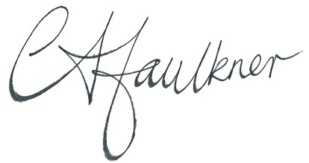
Date: | 3rd July 2023
Subject Leader: | 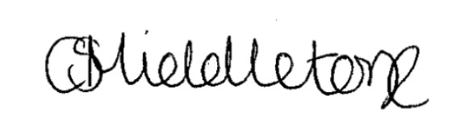
Date: | 3rd July 2023
Governor: | 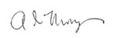
Date: | 12th July 2023

