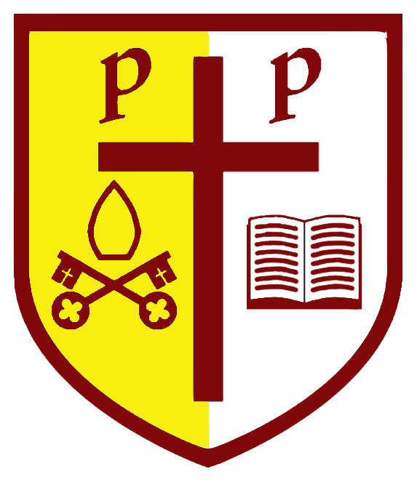
SS Peter and Paul Catholic Primary
End of Key stage data 2018

Key Stage Two
 | Sch ARE | Nat ARE | +/- | Sch GD | Nat | +/- | Ave scaled score sch | Ave scaled score Nat | +/- | Progress measure
Reading | 100% | 75% | +25% | 41% | 28.1% | +12.9% | 109.1 | 105.1 | +4 | +4.9
Writing | 88% | 78% | +10% | 18% | 20% | -2% | - | - | - | +1.5
Maths | 88% | 76% | +12% | 35% | 23.6% | +11.4% | 105.6 | 104.4 | +1.2 | +2.5
SPAG | 94% | 78% | +16% | 53% | 34.4% | +18.6% | 108.7 | 106.2 | +2.5
RWM | 82% | 64% | +18% | 12% | 10% | +2% | - | - | -
The cohort were 17 children =6% each

Key Stage One
 | School ARE | National ARE 2017 | +/- | School GD | National GD 2017 | +/-
Reading | 71% | 76% | -5% | 24% | 25% | -1%
Writing | 67% | 68% | -1% | 14% | 16% | -2%
Maths | 67% | 75% | -8% | 29% | 20% | +9%
RWM | 67% | 63% | +4% | 10% | 11% | -1%
The cohort were 21 children =4.7% each

Phonics
Children achieving phonics at the end of year one = 74%
Retakes in year two = 95%
EYFS
This year we have attained 63% Good level of devleopment

