Fluency progression 22-23
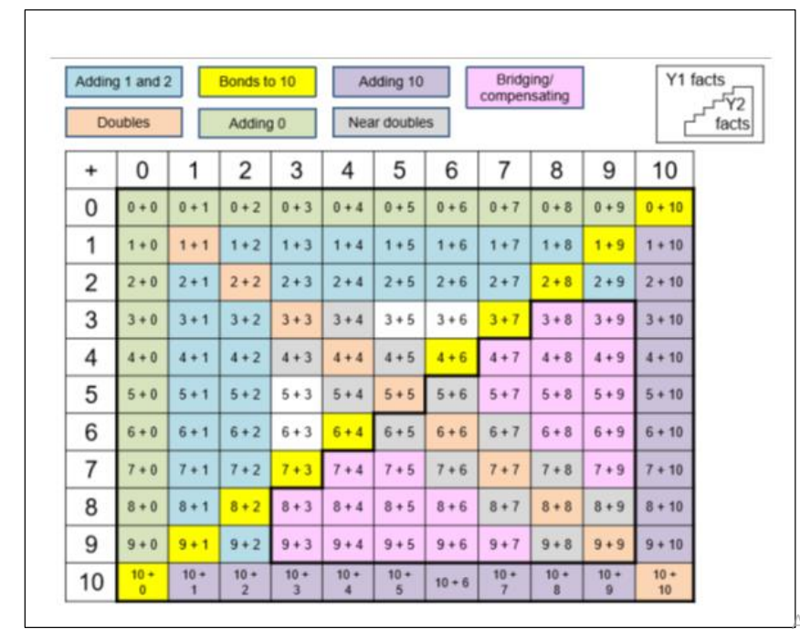
Year 1 pupils
Rapid recall
Y1 facts on grid – including associated subtraction facts
Mental strategies
+ 0 + 1 and + 2 (and –) to any number up to 20 (Just 0, 1, or 2 more/less)
+/- 10 to any 1 digit number including zero:10 + 7 = 17
Notice Number bonds to 10
Doubling and halving: double facts and halves to 5 + 5 (and 10 + 10)
Near number bonds to add two one digit numbers: "7 + 2 = 9 because 7 + 3 = 10 so it's just one less" or “8 + 3 must be 11 because 8 + 2 = 10”
Near double facts e.g. "3 + 4 = 7 because double 3 is 6 so it's just one more".
Partitioning: Use number facts to add TO + O: “24 + 3… I know that 3 + 4 = 7 so 20 + 7 = 27”
Adjusting: ‘make ten’ supported by models and images e.g. 8 + 6 = 8 + 2 + 4

Year 2 pupils
Rapid recall
Y1 and 2 facts on grid – including associated subtraction facts
2, 5 and 10 times table multiplication and division facts
Mental strategies
Number bonds to 10 and near number bonds to add two or three single digit numbers
Spot doubles and near doubles to add two or three single digit numbers
Use number bonds to 20 and near number bonds to 20 to add 2 numbers
+ 10 to any 2 digit number (support with models, images and hundred square)
Partitioning: Calculations with whole numbers which do not involve crossing place value boundaries- e.g. 23 + 45= 40 + 5 +20 + 3 or 40 + 23 + 5
Counting on or back in tens and ones to add or subtract – flexibility with number line
Adjusting +/- 9 and 11 by adding 10 then subtracting or adding 1
Adjusting: ‘make ten’ supported by models and images e.g. 8 + 6 = 8 + 2 + 4
+/- multiples of 10 where the answer is between 0 and 100 (e.g. 70 + 30 = 100, 20 + 40 = 60)
Doubling and halving: Derives doubles and halves of multiples of 10 up to 100
Doubling and halving: Find the doubles to 100 using partitioning and halves of any even number to 100

Year 3 pupils
Rapid recall
3, 4 and 8 times table and associated division facts
Multiply 2 digit number by 10
+/- multiples of 10 where the answer is between 0 and 100 (e.g. 70 + 30 = 100, 20 + 40 = 60)
Doubles and halves of multiples of 10 up to 100
Mental strategies
Counting on or back in fives from any multiple of 5 e.g. 35+15=? by counting on in steps of 5 from 35
Counting on or back in hundreds from any number e.g. 570 + 300= ? by counting on in hundreds from 570
Partitioning: Calculations with whole numbers which involves crossing place value boundaries e.g. 42 – 28= ? by 42 – 2 – 20 - 6
Adjusting multiples of 10 e.g. 38 + 68= ? by 38 + 70 – 2 or 45 – 29 = 45 – 30 + 1
Adjusting: ‘make ten’ progressing to multiples of ten e.g 28 + 13 = 30 + 11
Near doubles to numbers under 20 e.g. 18 + 16 is double 18 and subtract 2 or double 16 and add 2
Near doubles to multiples of 10 e.g. 60 + 70 is double 60 and add 10 or double 70 and subtract 10
Doubling and halving: Find the doubles and halves of any two-digit number and any multiple of 10 or 100– e.g. half 680 or double 73
Doubling and halving: Multiply and divide by 4 by doubling/halving twice and 8 by doubling/halving again. – e.g. 34 x 4 = 34 x 2 x 2.

Year 4 pupils
Rapid recall
All multiplication and division facts up to 12 x 12
+/- multiples of 10 beyond 100 e.g. 50 + 60 = 110
+ or – multiples of 100 up to 1000
Half of any even number to 100
Multiply and 2 or 3 digit number by ten
Mental strategies
Counting on or back in tenths and/or hundredths- e.g. 3.2 + 0.6 = ? by counting on in tenths. 1.7 + 0.55=? by counting on in tenths and hundredths – flexibility with a number line
Adjusting multiples of 10 or 100 e.g. 138 + 69= ? by 138 + 70 – 1 or 299 – 48 = 300 – 48 – 1
Adjusting ‘make ten’ progressing to 3 digit numbers e.g. 128 + 32 = 130 + 30
Partitioning: Calculations with decimal numbers not crossing place value boundaries then crossing boundaries. E.g. 3.2 + 2.1 progressing to 3.7 + 6.8
Near doubles to 100 e.g. 75 + 76 is double 76 and subtract 1 or double 75 and add 1.
Doubling and halving: Find the doubles and halves of any number up to 1,000 by partitioning

Year 5 pupils
Rapid recall
+/- multiples of 1000
Multiply and divide any number by 10 and 100
Halves of any number to 100 (e.g. half of 22 = 11, half of 51 = 25.5)
Squares of all numbers up to 12
Cubes of 2, 3, 4 and 5
Mental strategies
Adjusting multiples with decimals e.g 2 ½ + 1 ¾ by 2½ + 2 – ¼ or 5.7 + 3.9 by 5.7 + 4.0 – 0.1
Decimal near doubles to whole numbers e.g. 2.5 + 2.6 is double 2.5 add 0.1 or double 2.6 subtract 0.1.
Doubling and halving: Find the doubles and halves of any number up to 10,000 by partitioning – e.g. half of 32,202 by halving 3,000, 2000, 200 and 2 Doubling and halving: Multiply by 50 by multiplying by 100 and halving e.g. 8 x 50= 8 x 100 divided by 2
Doubling and halving: Double and half decimal number with up to one decimal place by portioning – e.g. half of 8.4 by halving 8 and halving 0.4

Year 6 pupils
Rapid recall
Multiplication of multiples of 10 and 100 based on known facts (e.g. 40 x 40 = 1,600);
Mental strategies
Adjusting multiples with decimals e.g 2 ½ + 1 ¾ by 2½ + 2 – ¼ or 5.7 + 3.9 by 5.7 + 4.0 – 0.1
Decimal near doubles to whole numbers e.g. 2.5 + 2.6 is double 2.5 add 0.1 or double 2.6 subtract 0.1.
Doubling and halving: Find the doubles and halves of any number up to 10,000 by partitioning – e.g. half of 32,202 by halving 3,000, 2000, 200 and 2 Doubling and halving: Multiply by 50 by multiplying by 100 and halving e.g. 8 x 50= 8 x 100 divided by 2
Doubling and halving: Double and half decimal number with up to one decimal place by portioning – e.g. half of 8.4 by halving 8 and halving 0.4

