SS Peter and Paul’s Catholic Primary School
Handwriting Policy

Importance and Nature of Handwriting
Handwriting is a means of recording language on paper, using a generally understood system of symbols. It is an important life skill as a functional tool for expressing language and as part of self-image and expression of personality. Despite the increased use of computers for writing, the skill of handwriting remains important in education, employment and in everyday life.
At SSPP, we recognise that children’s ability to write well for the rest of their lives, depends on firm foundations of taught skills in their primary years.
The Curriculum 2014 divides writing skills into two dimensions:
- Transcription (spelling and handwriting)
- Composition (articulating ideas in speech and writing)

It requires that teaching develops children’s competence in both dimensions. ‘Writing also depends on fluent, legible and, eventually, speedy handwriting.’
At SSPP, we believe that effective teaching of handwriting can only be achieved through modelling. Teachers demonstrate letter formation and joins regularly and children practice by carefully copying and repeating. It is important to observe children writing to ensure they are forming letters correctly.

Teachers’ encourage children to:
Learn and practise appropriate and effective handwriting skills at each stage of development, continually working towards mature handwriting which is:

• Legible
• Presentable
• Comfortable
• Fluent
• Flexible
• Fast
• Automatic
• Sustainable

- For children to have opportunities to write in different styles and for different purposes across the curriculum.
- For all staff to use and model the agreed handwriting conventions outlined in this document, thus providing consistency and continuity throughout the school.
- Make provision for left handed children and for children who experience difficulties.
- Encourage personal satisfaction and pride in well- presented writing.
Children are taught handwriting in the following ways:
EYFS
- To engage in activities requiring hand-eye coordination.
- Use one-handed tools and equipment.
- Draw lines and circles using gross motor movement.
- Manipulate objects with increasing control.
- Begin to use anticlockwise movement and retrace vertical lines.
- Begin to form recognisable letters.
- Use a pencil and hold it effectively to form recognisable letters, most of which are correctly formed.

Throughout the Foundation Stage, children need lots of opportunities to develop:

- Physical control through large-scale movement such as outdoor play.
- Balancing, climbing, marching and moving to music.
- Manipulative skills such as using tools, cooking utensils and scissors.
- Fine motor control and hand-eye coordination, through activities such as jigsaws, threading, cutting and manipulating ‘small world’ equipment.
- The key movements underpinning letter formation should be introduced through large-scale movements, from the shoulder.
In the earliest stages children should make the movements symmetrically using both arms. Once the movement is firmly established in kinaesthetic memory, it can be reduced in scale using activities such as sky writing, using sticks in sand etc. and then reduced further in art activities using felt tip pens, crayons and pencils.

KS1
Year 1
Children are taught to:
- Sit correctly at a table, holding a pencil comfortably and correctly.
- Begin to form lower-case letters in the correct direction, starting and finishing in the right place.
- Form capital letters correctly.
- Form digits 0-9 correctly.
- Understand which letters belong to which handwriting ‘families’ (i.e. letters that are formed in similar ways) and to practise these.

- Make links with phonics and spelling.

Year 2
- Form lower-case letters of the correct size relative to one another.
- Start using some of the diagonal and horizontal strokes needed to join letters and understand which letters, when adjacent to one another, are best left not joined.
- Write capital letters and digits of the correct size, orientation and relationship to one another and to lower case letters.
- Use spacing between words that reflects the size of the letters.

KS2

Year 3 & 4
Use the diagonal and horizontal strokes that are needed to join letters and understand which letters, when adjacent to one another, are best left not joined
Increase the legibility, consistency and quality of their handwriting, e.g. by ensuring that the down strokes of letters are parallel and equidistant; that lines of writing are spaced sufficiently so that the ascenders and descenders of letters do not touch.

Year 5 & 6
Write legibly, fluently, with increasing speed and personal style by:
Choosing which shape of a letter to use when given choices and deciding, as part of their personal style, whether or not to join specific letters.

Choosing the writing implement that is best suited for a task (e.g. quick notes, letters).

Joined Handwriting Style
In EYFS children are taught the correct letter formation of each letter.
We introduce joined up handwriting at an early stage of a child’s development, when the child is ready usually in Year 1.

Letter formation taught in EYFS
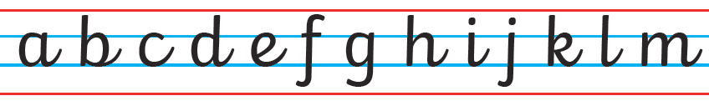
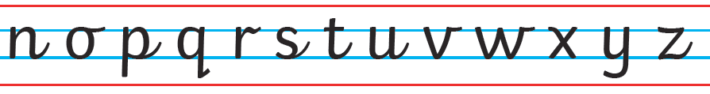

Letter formation taught from Year 1 upwards
