Y4/5 Homework Planner – Friday 30th September 2022
Subject | Activities
English | Reading: Please ensure you read every day to a family member and write in the book title and pages read each time you read. Please get your adult to comment and sign before handing it to be changed on Fridays. You can write in titles of books you read at home as well.  Read Theory: Please complete a comprehension on Read theory. Password is read2223.  Spelling: Please go on Spellshed to practice your spelling rules taught this week. If you have been given a Nessie log-in you can go on this also. Please learn the below spellings for a test next week.  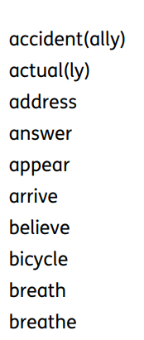
Maths |  | Times Tables: All children have access to Times Tables Rockstars. Please can you log on and practice 10 minutes daily over the next week, so we can identify any areas of weakness to target. This week we are revising our 3x table please learn these facts ready for a test next week.  Also, please complete the addition homework on sheets enclosed.
Music | Please practice playing your Ukulele over the weekend and return back to school on Monday. Use link https://www.youtube.com/watch?v=EbBquaOP4Ws  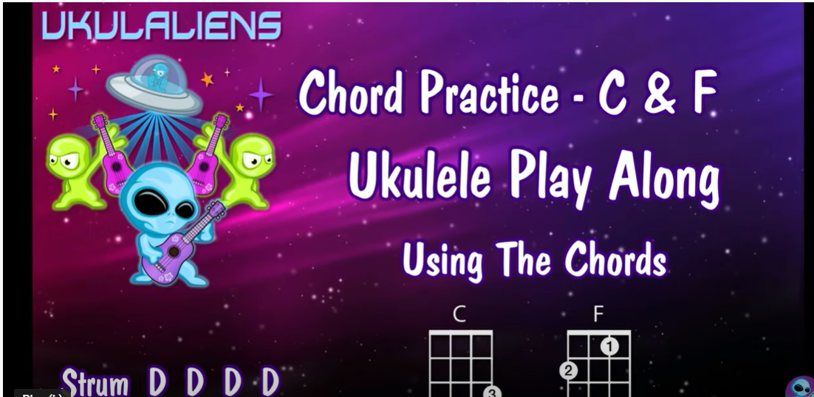

Email

In English we are writing a story based on the TWITS by Roald Dahl. In Maths we have been learning to add using a formal column method of up to 4 digit numbers. In Science we completed an experiment testing picnic plates. In ICT we are learning about the internet and in RE we have been using drama to understand the calling of Jacob. Please email or telephone Mrs Spurgin over the week if you need any help or have any concerns. aspurgin@st-peter-st-paul.staffs.sch.uk Homework and reading books are handed out on a Friday and returned on a Thursday

