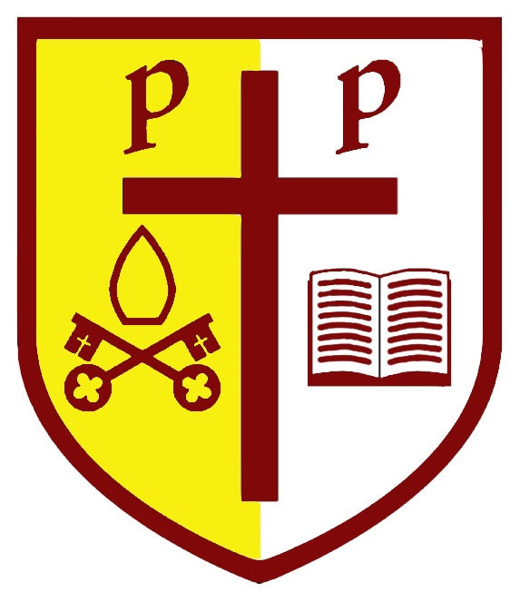

SS Peter and Paul Catholic Primary
Remote Learning Statement

Remote education provision: information for parents
This information is intended to provide clarity and transparency to pupils and parents or carers about what to expect from remote education where national or local restrictions require entire cohorts (or bubbles) to remain at home.
For details of what to expect where individual pupils are self-isolating, please see the final section of this page.

The remote curriculum: what is taught to pupils at home
A pupil’s first day or two of being educated remotely might look different from our standard approach, while we take all necessary actions to prepare for a longer period of remote teaching.

What should my child expect from immediate remote education in the first day or two of pupils being sent home?
Initially, children will be sent home with paper based pack of work, this will be mainly in English and Maths.

Following the first few days of remote education, will my child be taught broadly the same curriculum as they would if they were in school?
- We teach the same curriculum remotely as we do in school wherever possible and appropriate. However, we have needed to make some adaptations in some subjects. For example, some of the tasks may be adapted to meet the needs of the pupils at home and the resources they have available to them.

Remote teaching and study time each day

How long can I expect work set by the school to take my child each day?
We expect that remote education (including remote teaching and independent work) will take pupils broadly the following number of hours each day:
Key Stage 1 | 3 hours
Key Stage 2 | 4 hours

Accessing remote education

How will my child access any online remote education you are providing?
Online work for EYFS is through their YouTube channel and tapestry.
Years1-6 have made their online learning available through Microsoft TEAMS

If my child does not have digital or online access at home, how will you support them to access remote education?
We recognise that some pupils may not have suitable online access at home. We take the following approaches to support those pupils to access remote education:
If you do not have access to a suitable device in your home to support your child’s learning please contact the school office where we can support you in the loan of a laptop or IPad. You will need to sign a user agreement on receipt of the device.
If you do not have online access and are facing a lengthy time for online learning (Such as a national lockdown), we have a limited amount of SIM cards with data available for three months use – again in order to access this please contact the school office.
We can make paper-based copies available to those who request it- again through the school office. School Office is available on 01543 226090

How will my child be taught remotely?
We use a combination of the following approaches to teach pupils remotely:
In the event of school closure to all but key worker and vulnerable children the remote learning will be:
- live teaching a lesson a day in Y5/ and a session a week for catch up in all other classes
- recorded teaching with powerpoints and other resources
- printed paper packs produced by teachers (e.g. workbooks, worksheets)
- weekly reading books sent home
- work set on websites such as Timetables rock stars, numbots, read theory, spelling shed and my maths.
In the event of a bubble closure the above will continue to apply. In the event of isolation of an individual pupil, then work will initially be paper based, then work will be emailed directly to parents from the class teacher.

Engagement and feedback

What are your expectations for my child’s engagement and the support that we as parents and carers should provide at home?
- Children should be encouraged to engage in all online and paper-based learning. The parents should support this. If there is an issue then this needs to be brought to the attention of the child’s teacher who can discuss this matter further.

How will you check whether my child is engaging with their work and how will I be informed if there are concerns?
Children’s engagement will be monitored through presence on TEAMS, collection of paper based resources and engagement in live lessons.
Any child who is not engaging will initially be contacted by the class teacher, if this does not improve, there will be a phone call or home visit from a member of the SLT.
A warning letter may be sent if engagement is still found to be lacking.

How will you assess my child’s work and progress?
Feedback can take many forms and may not always mean extensive written comments for individual children. For example, whole-class feedback or quizzes marked automatically via digital platforms are also valid and effective methods, amongst many others. Our approach to feeding back on pupil work is as follows:
- In a school closure for a period of time, children will return their work to school on a weekly change over day. This work will be marked by the class teacher and returned the following week.
- In a bubble closure/ child isolation, children will bring work back to school after the isolation period and this will be marked by the class teacher and returned to the teacher.

Additional support for pupils with particular needs

How will you work with me to help my child who needs additional support from adults at home to access remote education?
We recognise that some pupils, for example some pupils with special educational needs and disabilities (SEND), may not be able to access remote education without support from adults at home. We acknowledge the difficulties this may place on families, and we will work with parents and carers to support those pupils in the following ways:
We will work closely with parents to support home learning as best we can. In liaison with parents we may modify tasks to meet the needs of the children, including practical rather than written for our youngest children. We will also ensure any additional resources needed to support learning are made available. Some of our SEND children prefer paper based learning and this can be made available as an alternative to the online work
1:1 sessions timetabled with a TA to support social, emotional and academic needs of those SEND children in Y4,5 and 6.

Remote education for self-isolating pupils
Where individual pupils need to self-isolate but the majority of their peer group remains in school, how remote education is provided will likely differ from the approach for whole groups. This is due to the challenges of teaching pupils both at home and in school.

If my child is not in school because they are self-isolating, how will their remote education differ from the approaches described above?
This has been described in the other sections of this document.
Resources will be provided by your class teacher by email and photocopiable packs that can be dropped on your doorstep.

