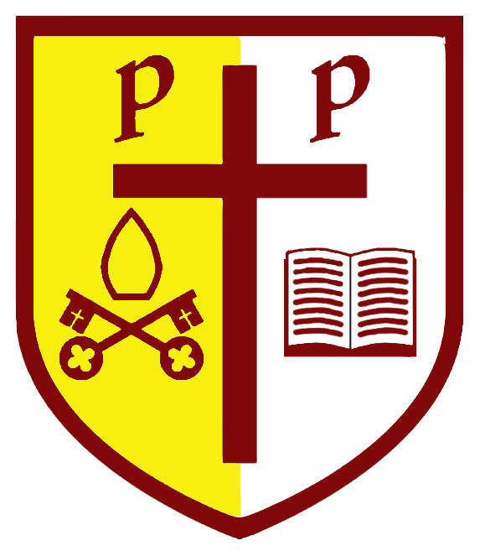
SS Peter and Paul Catholic Primary
End of Key stage data 2019

Key Stage Two
 | Sch ARE | Nat ARE | +/- | Sch GD | Nat | +/- | Ave scaled score sch | Ave scaled score Nat | +/- | Progress measure
Reading | (72) | 73 | (-1) | (18) | 26.9 | (-8.9) | 105 | 104 | +1 | +3.52
Writing | (72) | 78 | (-6) | (27) | 20.2 | (+6.8) |  |  |  | -0.46
Maths | (91) | 79 | (+12) | 18 | 26.6 | -8.6 | 106 | 105 | +1 | +1.61
SPAG | (82) | 78 | (+4) | (36) | 35.7 | (+0.3) | 106 | 106 | =
RWM | (64) | 65 | (-1) | 0 | 10.5 | -10.5
The cohort were 12 children =8% each

Key Stage One
 | School ARE | National ARE 2017 | +/- | School GD | National GD 2017 | +/-
Reading | 67 | 74.9 | -7.9 | 22 | 25 | -3
Writing | 67 | 69.2 | -2.2 | 17 | 14.8 | +2.2
Maths | 67 | 75.6 | -8.6 | 17 | 21.7 | -4.7
RWM | 61 | 64.9 | -3.9 | 11 | 11.2 | -0.2
The cohort were 18 children =6% each

Phonics
Children achieving phonics at the end of year one = 75%

Retakes in year two = 83% only one child did not pass in the year two retakes.

EYFS
This year we have attained 67% GLD national was 71.8%.

